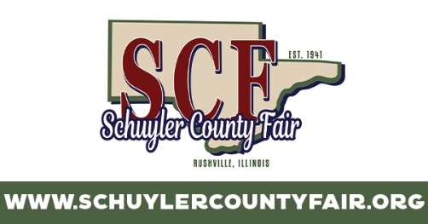
2024 Schuyler County Fair Schedule
Friday, June 28
Noon Gates Open
6-9pm Kid Zone
4:30pm ITPA Garden Tractor Pull
6:30pm Tractor Pull
9:30pm The Stone Cold Cowboys (Entertainment Pavilion)
Saturday, June 29
Noon Gates Open
6-9pm Kid Zone
7:30pm Gavin Adcock opening for Gary Allan at 9pm
10pm The Brat Pack (Entertainment Pavilion)
Sunday, June 30
Noon Gates Open
9am Church Services
2pm Bags Tournament (Entertainment Pavilion)
4pm Kiddie Tractor Pull Qualifying (Merchants Building)
5pm 1 Hour Free Carnival
6-9pm Kid Zone
5pm Horse Races
Monday, July 1
8:30 Goat Show
1-3pm Positively Senior Day (65 & over get in free during this time)
5pm Kiddie Tractor Pull Final (Merchants Building)
6-9pm Kid Zone
5:30pm Talent Contest
6:30pm Little Miss & Mister Pageant
8pm Queen Contest
Tuesday, July 2
6-9pm Kid Zone
7pm Tough Truck / Monster Truck
Wednesday, July 3
8am Cattle & Swine
6-9pm Kid Zone
7pm Rodeo
9:30pm Ivory Brothers Dueling Piano (Entertainment Pavilion)
Thursday, July 4
8am Cattle & Swine
1pm Mud Sling 5pm Derby
5-8pm Kid Zone 9:30pm Fireworks

