2025 Schuyler County Fair Schedule
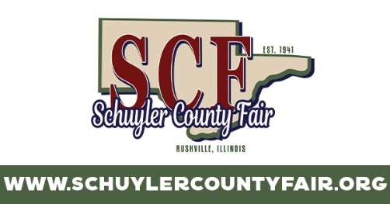
Sun Jun 29: 8:30am Goat Show
9am Church Services
2pm Bags Tournament (Entertainment Pavilion)
3-5pm FFA Games (Livestock Show Arena)
5pm 1 Hour Free Carnival
7pm Rodeo

Mon June 30: 1-3pm Positively Senior Day (65 & over get in free during this time)
6pm Kiddie Tractor Pull Qualifying (Entertainment Pavilion)
6-9pm Kid Zone
6pm Harness Racing

Tues July 1: Petting Zoo & Pony Rides
Noon Harness Racing
5:30pm Talent Contest
6:30pm Little Miss & Mister Pageant
8pm Queen Contest
6-9pm Kid Zone

Wed July 2: Petting Zoo & Pony Rides
4pm Gates Open
6pm Kiddie Tractor Pull Final (Entertainment Pavilion)
7pm Tough Truck & Combine Derby
6-9pm Kid Zone

Thurs July 3: Petting Zoo & Pony Rides
6-9pm Kid Zone
7:30pm Nate Smith with special guest Josh Ross
10pm Brat Pack (Entertainment Pavilion)

Fri July 4: Petting Zoo & Pony Rides
8am Cattle & Swine
1pm Mud Sling
4:15pm Power Wheels Derby
5pm-8pm Kid Zone
5pm Derby
6:30pm Pee Wee Livestock Show
9:30pm Fireworks
9:30pm DJ Rick (Entertainment Pavilion)
Sat July 5: Petting Zoo & Pony Rides
8am Cattle & Swine
4:30pm ITPA Garden Tractor Pull
6-9pm Kid Zone
6:30pm Tractor Pull
9:30pm Silverlake (Entertainment Pavilion)

